The Relevance of Press Freedom on the Narratives Concerning the Covid-19 Crisis

Marco Tinga

01/06/2020

INTRODUCTION

The Covid-19 pandemic, and the social and economic crisis it is causing, may change the way we understand basic concepts as the respect for human rights, freedom of expression, and the importance of access to universal healthcare. However, the debates that are arising from the crisis are inevitably of a political nature too. With many questioning the ability of democracies to confront the harsh development of the situation. In fact, in the past months, there have been increased debates as to whether liberal democracies are able to effectively tackle the ongoing pandemic, with some speculating that such doubts may lead to an erosion in democratic values and institutions. Preliminary analyses of data concerning the number of coronavirus cases and deaths from 159 countries observed, have shown a positive correlation between authoritarianism and a greater resilience to the predicaments of the pandemic. A plausible explanation may consist in authoritarian regimes’ lack of restrictions in the use of police and military force to coerce the people in respecting the extreme measures of containment. However, before rushing into accepting a similar interpretation, in this paper we will argue the necessity of taking into account different factors that may explain more reasonably these initial numbers on the spread of the virus. Specifically, it will be argued here that no inference should be made on the ability of a government, or lack thereof, to tackle down the spreading of the virus, without considering how the availability and reliability of reported number of cases and deaths related to the virus is strictly correlated to the quality of a state’s healthcare system and the level of freedom of the press that said state can grant to its citizens and its professionals. More than proposing here a ground-breaking theory on the correlation between freedom of expression, healthcare quality and the ability of a state to respond to a crisis of almost unprecedented proportions, the intent of this paper will be to deconstruct this almost positive narrative over authoritarianisms, that we believe to be dangerous, and that often re-emerges in similar fashion every time democracies face social, economic or health crises comparable to this latest one caused by Covid-19. It is argued here that not only this narrative is dangerous for the obvious political implications that derives from it, such is the very reasonable possibility that more autoritarian states could use the Covid19-crisis as an excuse to disregard basic human rights enforcement(Herszenhorn, 2020). We also believe,as we hinted above, that this correlation could be deconstructed when taking into account other factors that can control for, and consequentially counter, this distorted narrative. Our expectation is to prove a solid correlation between a state’s high level of press freedom and quality and access to its healthcare system, and show that, to high levels of press freedom and healthcare quality correspond also higher scores on the Vdem democracy index. It follows that if a country that is at the same time, more democratic, can provide its citizens easier access to an healthcare system of greater quality, and can grants its professionals and journalists an acceptable level of press freedom, its corona numbers are higher much likely because they are actually addressing the situation and providing more reliable information, in a more transparent and trustworthy manner. In contrast to less democratic regimes with lower standards both for healthcare quality and freedom of the press.  
It is true that correlation does not prove causation, and as political scientists we should never forget this. However, providing a solid correlation considering a wider range of factors could be really helpful when our aim is to deconstruct and reject a weaker correlation, that if not countered, will generate support for dangerous narratives, that should be instead avoided in a similar precarious moment.

FREEDOM OF THE PRESS AND QUALITY AND ACCESS TO HEALTHCARE

Why these control variables?

As it has been already noted, as it happens in war, in global pandemics too, the first casualty on the field is truth (Unesco,2020). Truthfully the simple fact is that “[…]particularly in the face of a global pandemic, the free flow of information, unhindered by threats and intimidation and penalties, protects life and health and enables and promotes critical social, economic, political and other policy discussions and decision-making” (Human Rights Council, 2020). In fact, in less than two months that this pandemic has literally gone viral, many cases of Press suppression and censorship, even by means of violence, have been reported, where often the interested government was directly or indirectly involved in the matter (Unesco. 2020). This is the reason why the freedom of the press has been selected as one of our main control variables in the model we are going to propose in this paper. Specifically, we will refer to the World Press Freedom Score provided to us by Reporters sans Frontieres.The score goes from a value of 0 to 100, with values closer to 0 indicating higher levels of press freedom. In a similar fashion, a control variable as much relevant as press freedom will be the level of quality and access to healthcare, that we consider a good measure of the overall quality of healthcare that a state can provide to its citizens and that can give us a better perspective on a state’s ability to counter the spread of the virus. In this case, we will refer to the HAQ Index as proposed by the Global Burden of Disease Study. The score goes from a value of 0 to 100, with values closer to 100 indicating higher levels of access and quality to healthcare. Finally, our control variables for democracy are provided by the Varieties of Democracy’s project (Vdem) codebook. Specifically, the indicators for Polyarchy, Participatory Democracy and Liberal democracy, as present in the re-elaborated dataset provide by Dr. Babak Rezaee Daryakenari. As we shall discuss in detail in the paper later on, when categorized, those indicators of democracy are really useful to compare how more or less democratic tendencies compare with higher or lower level of press freedom and healthcare quality. Last but not least, in our final model, we shall also include the levels of healthcare expenditure of a country (on its total GDP), for a more comprehensive and solid presentation, in order to account for the fact that healthcare quality alone could not be an indicator enough, since now always at high levels of expenditure correspond higher level of quality. As a last note, for academic transparency, we must mention that for this paper it has been initially consider to include as additional control variables both the number of reported tests and the Transparency index, which for some could be considered more comprehensive and complete than the Freedom of The Press score. However, two factors have moved us to reconsider this initial idea. First and Foremost, for the nature of the still low number of countries that are making test reports readily available, to control for tests number means to almost cut by half our number of observed countries, that is our sample, heavily undermining the solidity of our model. In the matter of the Transparency index, initial test models that used this score instead of the Freedom of the Press score, showed that using this variable instead of press freedom undermined the solidity and validity of our claims due to considerable high levels of statistical insignificance for this coefficient. Nonetheless, for a matter of clearness, we are still including the Transparency index related dataset for whoever should consider to re-run our models exchanging the Press Freedom variable with the Transparency one.

METHODOLOGY

In our research, our dependent variable for the final model will be the number of deaths, normalized for the total of the population. We will control, as suggested in the introduction, for the effect of freedom of the press, access and quality of healthcare, level of democracy, and in a second model we will also include the control variable of healthcare expenditure. To deconstruct the dangerous narrative discussed in the introduction, we expect to see a model where at an increase of (reported) deaths, it will correspond higher quality of healthcare, press freedom, healthcare expenditures and democracy. To make our case, in the first section of the paper we will analyse how the main control variables correlates individually with the number of cases and or deaths and the type of democracy. We will show the distribution of these variables, and when necessary we will propose simple linear models, or boxplots to visualize the initial findings. At the end of this section we will also discuss why, for a matter of practicality, in the final model we will consider only participatory democracy as the control variable for higher or lower level of democracy, instead of proposing three almost identical final models for each of the three Vdem variables included in the dataset. Remarks and analysis of the partial findings will be discussed as they are presented. In the second half of the paper we shall propose our final model, that will control for all the variables, but we shall arrive at it in two steps. A first one where we will not include Healthcare expenditure as a control variable, and a final one where we will do so. For both models we will test the BLUEness (respecting the Gauss-Markov Assumptions)of our findings and we will try to correct eventual criticalities, before proposing our conclusions. Last note on methodology: in the individual analyses of the variables, for practicality only the number of cases and deaths shall be considered as logged value (log), whereas in the final models that will include all of them at the same time, all of the variables will be logged.

Let Us Begin

SECTION I

To start, we shall simply visualize the distribution of our control variables 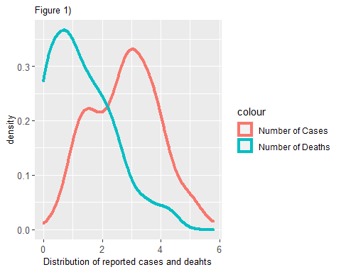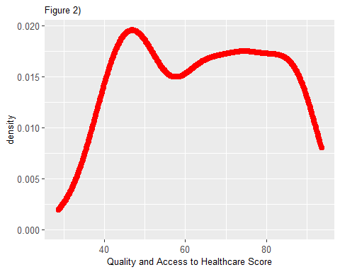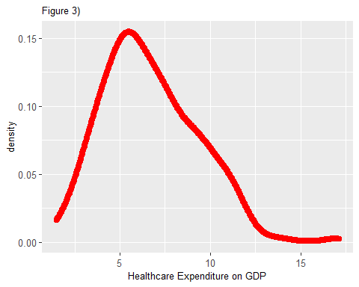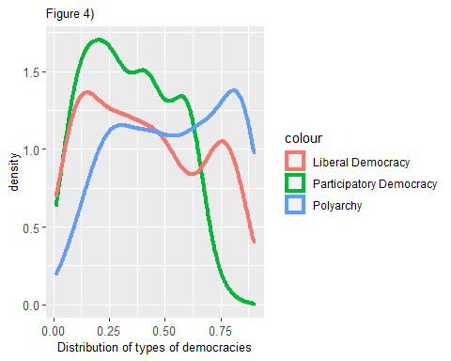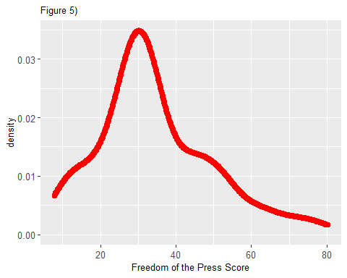

From the start, figure 1) tells us that the highest numbers of reported deaths are higher than the highest numbers of reported cases, and in any case, the most reported number of deaths and cases are of a considerable value. This simply confirms what we already know on the seriousness of the situation and the dangerous threat that the virus represents in general terms.

Figures 2) and figure 3), when compared, start depicting the first interesting factor. While it appears that lower and higher score on the quality of healthcare are somewhat evenly distributed mostly from a lower score of 40 to and highest of 80 (the closer to 100, the better), when it comes to healthcare expenditure on total of GDP, it appears that the majority of observation are spending lower portions of their GDP for their healthcare system. The marked difference of distribution from the two figure (2 and 3) suggests that higher or lower levels of expenditure are not directly correlated to higher or lower level of access and quality of healthcare, supporting our claim that we will eventually need to control for both those variables in our final model.

What is important to note in figure 4) is how, amongst the three indices of democracy from the Vdem project, the one that shows the highest number of lowest score is Participatory Democracy. Given the nature of our argument, this is the variable we are going to use as a control variable for democracy. In the next section, by use of different box plot, we will further explain the reason for this selection for the final models.

Finally, figure 5) immediately shows the first valuable hint for our investigation, suggesting that most of the observed countries in our sample scored a value around 30 on the Freedom of the Press score. It is indeed an acceptable score, if we take into account that this index considers values closer to zero as representative of good levels of press freedom. If we combine this consideration with what we have seen on the distribution of reported cases and, most importantly, reported deaths, we can already start to consider the possibility that the correlation between democracies and higher number of deaths may be understood under a different light than the one we have referred to in the introduction as the “dangerous narrative” over more autocratic government.

The next step of this first section will consist in analysing how the different indicators of democratic regimes and their lower or higher democracy score correlate with the number of reported cases and reported deaths.

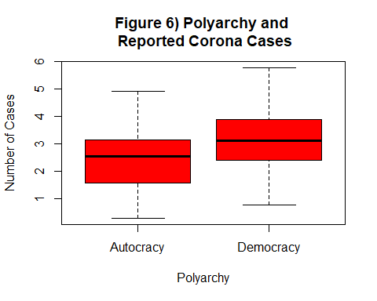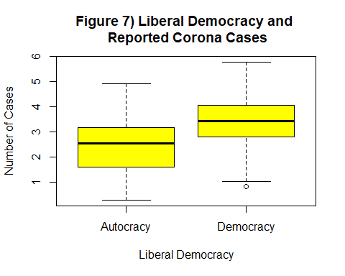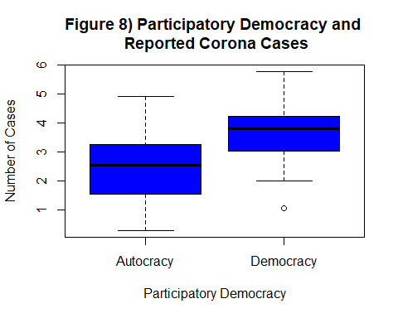

As we can observe in Figures 6, 7 and 8, no matter what kind of Democracy we are considering, the higher the Vdem score (the more democratic tendency, so to speak), the higher seems to be the number of reported cases. As we are expecting and as it will be showed below, a similar picture will be depicted when considering reported deaths.

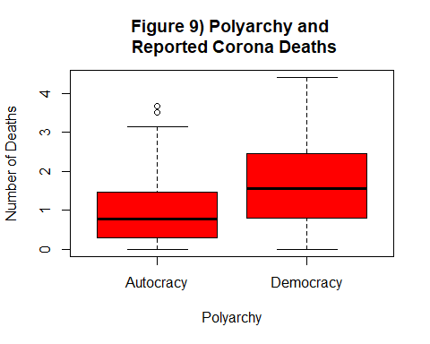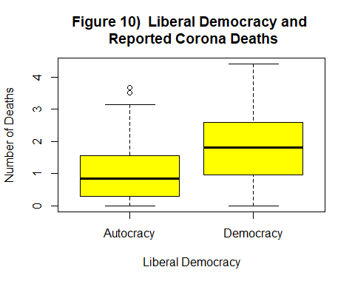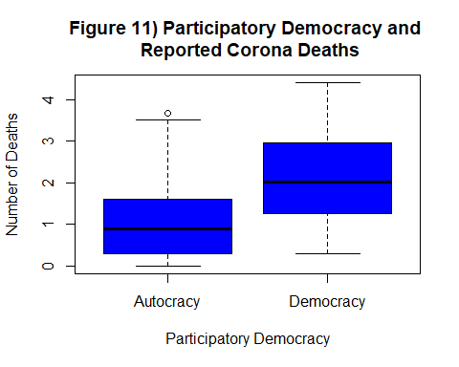

Once more, as with the number of cases, the higher number of reported Corona deaths are correlated, not matter what indicator of democracy considered, to those observed countries in our sample that scored higher on the Vdem index. Most notably, if we consider figure 8) and figure 11), in both cases the indicator for participatory democracy is the one that shows the largest gap between more democratic or more autocratic tendency in comparison with the number of reported cases and reported deaths. In fact the gap is noticeable both by comparing the means of reported deaths and cases between more autocratic or more democratic, and if we consider how little the confidence intervals overlap in comparison to the other two Vdem indicators. As mentioned earlier, this is the second consideration that has lead us to select this indicator of democracy as the control variable for democracy in the final model we will propose in the second section.

For the reason that, in this first section, we are still only looking for simple correlation, we are going to consider some simple linear models, comparing the number of reported deaths with the levels of healthcare quality and freedom of the press(separately). For the reader it is important to note that from now onwards we shall consider the number of reported deaths as our only dependent variable. The reason for this decision is that for our argument on the importance of transparency on the reported numbers of Corona casualties, cases and deaths can cover a similar role as dependent variables, as the graphs proposed earlier and the related analyses should have clearly showed. Our first simple linear model will compare the number of deaths (our dependent variable) with the levels of quality and access to healthcare (independent variable). We remind the reader that at higher score on the HAQ index correspond, intuitively, higher levels of quality.

##   
## Figure 12) Number of Deaths compared to Healthcare Quality - OLS Summary  
## ==========================================================  
## deaths_log   
## ----------------------------------------------------------  
## Health_AQ 0.038***   
## (0.004)   
##   
## Constant -1.119***   
## (0.274)   
##   
## Observations 159   
## R2 0.354   
## Adjusted R2 0.350   
## Residual Std. Error 0.875 (df = 157)   
## F Statistic 86.056*** (df = 1; 157)   
## ----------------------------------------------------------  
## Notes: ***Significant at the 1 percent level.  
## **Significant at the 5 percent level.   
## *Significant at the 10 percent level.

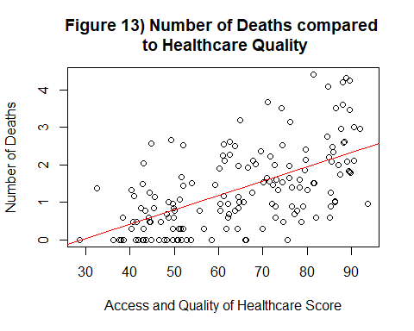

On figure 12) we can observe that our explanatory power (R square) and our coefficients for this model are statistically significant. Furthermore, as expected, and even if at a first glance could be counterintuitive and in support of the dangerous narrative we are trying to reject, at higher level of healthcare quality seem to correspond and higher number of deaths caused by the Corona virus. Since we have to keep in mind that we are always considering those numbers as the official reported numbers as provided by the countries observed, we can clearly state that countries with better healthcare have also reported higher numbers of deaths. As a next step, we argue the necessity to compare, in a similar fashion, how the number of deaths reported by these countries compares to their score on the Freedom of the Press score.

In this second simple linear model, we shall compare then the number of reported deaths with the Freedom of the Press score. As a note to the reader, in this case, for the Freedom of the Press Score, the closer to zero, the higher the level of press freedom.

##   
## Figure 14) Number of Deaths compared to Freedom of the Press - OLS Summary  
## ==========================================================  
## deaths_log   
## ----------------------------------------------------------  
## Press.Freedom.Score -0.015***   
## (0.006)   
##   
## Constant 1.858***   
## (0.209)   
##   
## Observations 159   
## R2 0.045   
## Adjusted R2 0.039   
## Residual Std. Error 1.064 (df = 157)   
## F Statistic 7.452*** (df = 1; 157)   
## ----------------------------------------------------------  
## Notes: ***Significant at the 1 percent level.  
## **Significant at the 5 percent level.   
## *Significant at the 10 percent level.

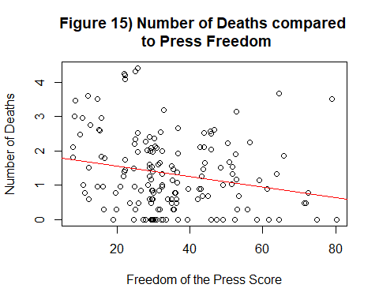

Similarly to what we have observed earlier, figures 14) and 15) depict a clear image of a situation where to better scores on the freedom of the press correspond a higher number of reported deaths, and the more we get close to 100, that means lower levels of press freedom, the lower becomes the number of reported deaths. Once again, as observable in figure 14), the explanatory power of this model is solid enough to satisfy our quest for correlation, and the statistical significance of our coefficients is more than acceptable. If we take into account this model and the previous one, our interest in considering the relevance of freedom of the press and healthcare quality becomes almost self-explanatory. Those initial observations suggest that controlling for press freedom and healthcare quality may help us in our attempt to reject a narrative that wants to depict an image where more autocratic regimes are simply more suited to tackle down the spread of the virus. We have doubted that a similar explanation was sufficient, and it would appear that we are going on the right direction.

To definetly seal this section of the analysis, we shall directly compare now how healthcare quality Scores compare to press freedom scores in our observed countries. We are expecting to see that at higher levels of healthcare quality (the closer to 100) will correspond higher levels of press freedom (the closer to 0).

This last simple linear model will plot the correlation between these two variables.

##   
## Figure 16) Healthcare Quality vs Freedom of the Press - OLS Summary  
## ==========================================================  
## Health_AQ   
## ----------------------------------------------------------  
## Press.Freedom.Score -0.388***   
## (0.082)   
##   
## Constant 77.552***   
## (3.105)   
##   
## Observations 159   
## R2 0.124   
## Adjusted R2 0.119   
## Residual Std. Error 15.834 (df = 157)   
## F Statistic 22.322*** (df = 1; 157)   
## ----------------------------------------------------------  
## Notes: ***Significant at the 1 percent level.  
## **Significant at the 5 percent level.   
## *Significant at the 10 percent level.

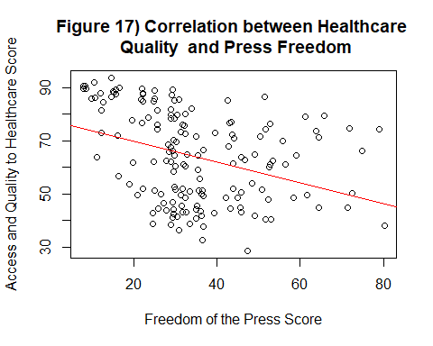

As expected, countries that can provide better levels of access and quality to healthcare for its citizens can also guarantee its journalist and professionals better levels of freedom of the press. Given the nature of the 0 to 100 score system of both indicators, that yet goes in opposite directions to indicate better levels of quality of healthcare and press freedom, the slope of our model is negative. Once more, the statistical significance of our coefficients is more than acceptable. Albeit our R square is not that high, we are still only looking for correlation at the moment, and we find our partial results to be satisfying.

Finally, to conclude the first section of this paper, we deem interesting to evaluate how the Freedom of the Press Score and the Access and Quality of Healthcare Score compare with the three indicator of democracy, and their more or less autocratic/democratic tendencies. We shall make use of some boxplots one last time.

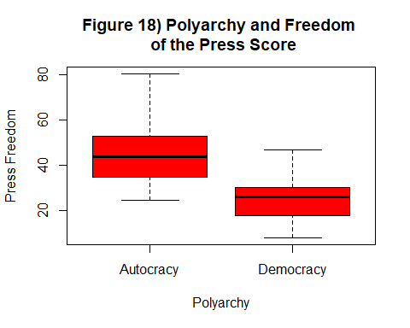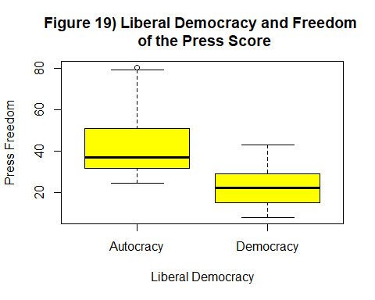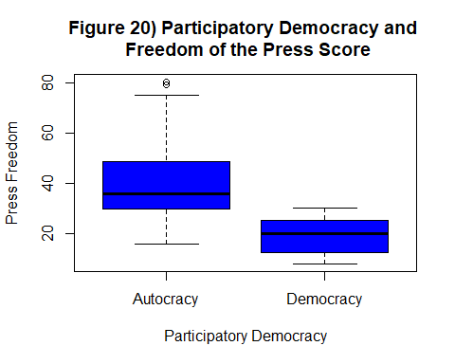

Very much intuitively, no matter what type of democracy we consider, the more democratic its tendency, the better the score on the Freedom of the Press (the closer to 0 the better). Furthermore, as noted earlier when comparing the type of democracies with the number of cases and the number of deaths, Participatory Democracy appears to show the most evident gap for both its mean and its confidence intervals between more democratic and more autocratic tendencies. We expect similar results when plotting boxplots that compare the Vdem variables with access and quality to healthcare.

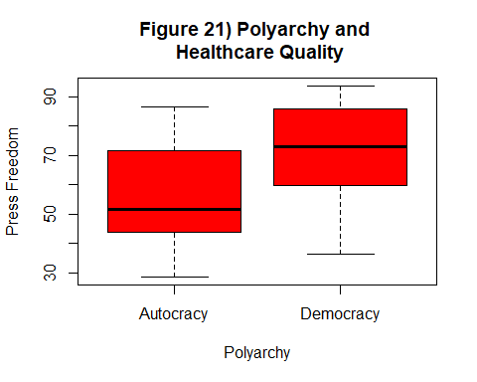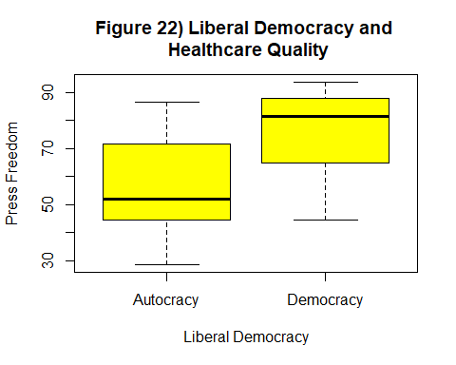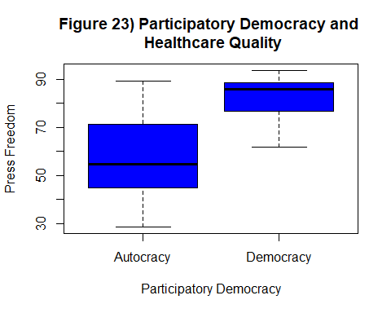

Figures 21), 22) and 23) shows us what we expected. Once more, for all of the three Vdem variables, the more democratic the tendency, the higher the score for the access and quality to healthcare is.Furthermore, similarly to what we have arleady noted, even in this case, the indicator for Participatory Democracy is the one that shows the largets gap of its mean and its confidence intervals between more autocratic or more democratic. Once more this last consideration solidifies our decision to consider Participatory Democracy as our control variable for democracy in the final model we shall propose in the second section of the paper, that now can finally be presented without further ado.

SECTION II

The above analysis on all the various variables we have presented in SECTION I was meant to thoroughly expose the reason for our selection and how these variables appear to be the best suited to our goal, that is to deconstruct the narrative that wants more autocratic regimes to be more suited, thanks to their use of state force, to tackle down the spread of the virus. We have argued that this narrative is dangerous, and most importantly, is flawed, because it does not consider how relevant is the freedom of the press and the quality of an healthcare system to actually depict a more reasonable and realistic description of the situation. We argue that it is most likely that the higher number of reported deaths (and cases) shared by democratic regimes are to be understood as the consequence of these regimes’ adherence to their higher social, civic and ethical values and their commitment on the availability, trustworthiness and sharing of information. In turn we have argued that this is correlated with their ability to guarantee higher standards of quality and access to their healthcare systems for their citizens.

What we will propose now is a comprehensive OLS model that will consider all the control variables already presented and scrutinized, and which will have the normalized number of deaths (per population) as our final dependent variable. We expect this model to be as consistent as possible with the individual results we have proposed in SECTION I.

##   
## Figure 24) Final OLS Model: analysing the normalized number of deaths and controlling for democracy, healthcare quality and press freedom  
## ==========================================================  
## norm_deaths   
## ----------------------------------------------------------  
## v2x_partipdem 0.288***   
## (0.086)   
##   
## Health_AQ 0.004***   
## (0.001)   
##   
## Press.Freedom.Score 0.002**   
## (0.001)   
##   
## Constant -0.273***   
## (0.060)   
##   
## Observations 158   
## R2 0.460   
## Adjusted R2 0.450   
## Residual Std. Error 0.105 (df = 154)   
## F Statistic 43.761*** (df = 3; 154)   
## ----------------------------------------------------------  
## Notes: ***Significant at the 1 percent level.  
## **Significant at the 5 percent level.   
## *Significant at the 10 percent level.

As we can observe in Figure 24) it would appear that all our control variables present statistically significant values, and most notably, our explanatory power, as suggested by R square, seems to be solid enough. However, plotting the effects of this model, and eventually test if it actually respects the Gauss-Markov Assumptions (BLUEness test), will help us better understands our findings, see if they are consistent with our initial analysis in SECTION I, and tells us if we need to make some corrections.

To start, we shall plot the various effect plots for the control variables. 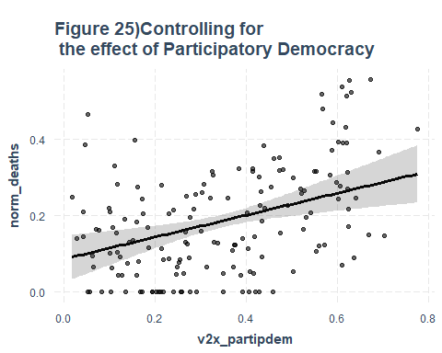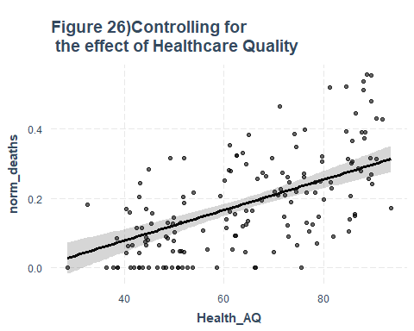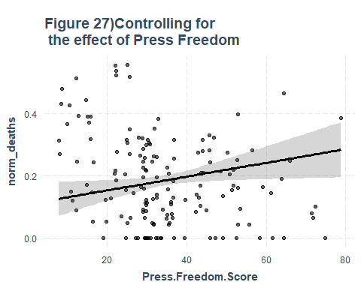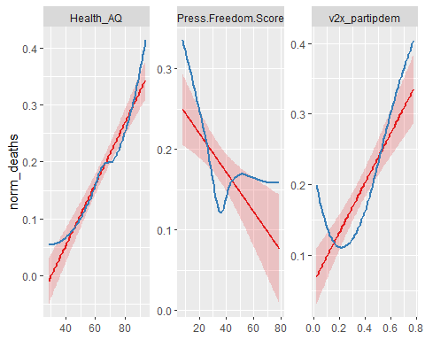

Figures 25), 26) and 27) clearly show an acceptable level of consistency on their effect on the final model with the individual findings we have discussed in SECTION I. It would appear that our model already in this state can depict a better picture than the narrative of autocratic regime that we are indeed trying to reject with this paper. However, no model can be fully considered if it does not reasonably respect the Gauss-Markov Assumptions. Furthermore, the last figures that plots in three different graphs the behaviour of the slopes for each controlling variables on the dependent variable, we can see that, albeit the already noticeable presence of outliers, the blue line representing the actual observations do generally respect the predict slope line (in red) of the model. It is indeed far from a perfect result, but the trend would already suggest that with the future availability of more data, from more countries, we may in fact confirm our assumptions.

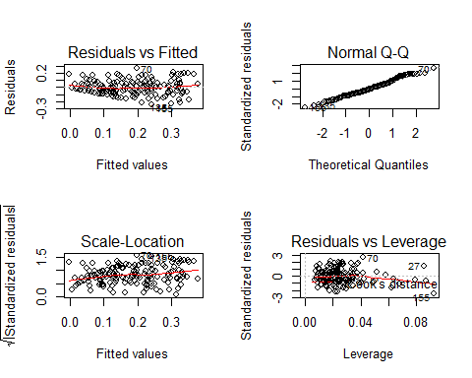

To begin with, in the Residual vs Fitted plot, we can observe that the linearity assumption is acceptably respected, however there clearly appears to be the presence of some outliers. The trend line here is reasonably close to a horizontal line, but we should still try to implement some corrections. Considering the Normal Q-Q plot, we can consider ourselves satisfied, because we can state the residuals appears to be normally distributed. Still, we can clearly observe some departures from the ideal line, confirming the presence of some outliers. We shall pay more attention to this later. In the Scale-Location plot which tests for homoskedacity, the presence of outliers is once again confirmed, and indeed, even if the spread of the points appears to be somewhat homogeneous, our trend line (in red) is not horizontal enough. It could be considered partially acceptable, which means that some corrections are in fact required. In the Residuals vs Leverage plot, we are finally controlling for the presence of outliers, whose presence we could suspect already from the previous plots. We can see that the majority of our observation depict a promising trend. However, the trend of the line clearly confirms the presence of relevant outliers. To make our much-needed corrections, we must identify those outliers and eventually removed them from our dataset. For a clear visualization of the outliers, we shall use the Cook’s distance plot.

## # A tibble: 3 x 12  
## .rownames norm_deaths v2x_partipdem Health_AQ Press.Freedom.S~ .fitted .se.fit  
## <chr> <dbl> <dbl> <dbl> <dbl> <dbl> <dbl>  
## 1 27 0.385 0.0470 74.2 78.9 0.241 0.0306  
## 2 70 0.464 0.0530 71.1 64.4 0.197 0.0213  
## 3 155 0 0.194 66.3 74.9 0.240 0.0318  
## # ... with 5 more variables: .resid <dbl>, .hat <dbl>, .sigma <dbl>,  
## # .cooksd <dbl>, .std.resid <dbl>

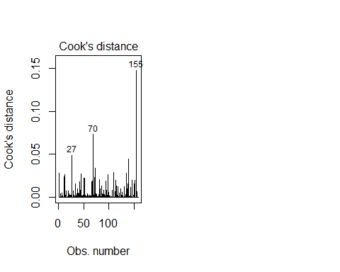

Now that we have identified the most noticeble outliers, we shall remove them from the dataset and re-run the BLUEness test. If this will not considerably alter our results, we shall consider two options. First, investigate the possibility of multicolinearity, considering how the indicator of democracy could autocorrelate with the freedom of the press. Secondly, we shall consider to include an additional control variable, Healthcar Expenditure on GDP, which, as we have seen in SECTION I, is not directly correlated with Healthcare Quality.

##   
## Figure 28) Final OLS Model (Clean Dataset): analysing the normalized number of deaths and controlling for democracy, healthcare quality and press freedom  
## ==========================================================  
## norm_deaths   
## ----------------------------------------------------------  
## v2x_partipdem 0.322***   
## (0.085)   
##   
## Health_AQ 0.004***   
## (0.001)   
##   
## Press.Freedom.Score 0.002**   
## (0.001)   
##   
## Constant -0.274***   
## (0.062)   
##   
## Observations 155   
## R2 0.484   
## Adjusted R2 0.474   
## Residual Std. Error 0.101 (df = 151)   
## F Statistic 47.179*** (df = 3; 151)   
## ----------------------------------------------------------  
## Notes: ***Significant at the 1 percent level.  
## **Significant at the 5 percent level.   
## *Significant at the 10 percent level.

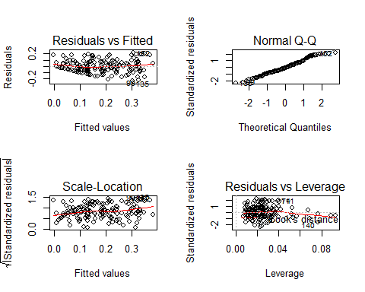

As Figure 28) shows, the values of our coefficients, our R square, and our F-statistic, are all statistically significant. However, as the re-run of the BLUENess test has exposed, we are still facing the problem of relevant outliers and we are not yet entirely satisfied with the results. As we have mentioned earlier, before considering the inclusion of an additional control variable or a second purge of the dataset, we shall run the VIF (Variance Inflation Factor) test for multicollinearity, to see if we are facing an autocorrelation problem with our democracy variable and our press freedom variable. We doubt it, because from the Vdem codebook, the indicator for Participatory Democracy should not consider the Freedom of the Press, even if others Vdem indicators do. Still, for our analysis we cannot give anything for granted.

## v2x_partipdem Health_AQ Press.Freedom.Score   
## 3.871513 1.456578 3.176558

It appears that the debate over under which values we can accept our results on the VIF test is still very much open and heatedly discussed. The most relaxed scholars argue that a value lower than 10 is acceptable, the more rigid argue that we should dismiss anything above 2.5, and some others compromise on values under 5. Considering that our variables interested in this test are both below the value of 4, we will consider ourselves satisfied with the results, and we can disregard the autocorrelation problem. Considered the results above, we shall attempt to clean the dataset from outliers a second time and re-rune the BLUEness test.

## # A tibble: 3 x 12  
## .rownames norm_deaths v2x_partipdem Health_AQ Press.Freedom.S~ .fitted .se.fit  
## <chr> <dbl> <dbl> <dbl> <dbl> <dbl> <dbl>  
## 1 74 0.556 0.673 88.7 25.0 0.369 0.0201  
## 2 111 0.479 0.568 89.5 8.63 0.301 0.0199  
## 3 140 0.0660 0.066 74.6 71.8 0.223 0.0280  
## # ... with 5 more variables: .resid <dbl>, .hat <dbl>, .sigma <dbl>,  
## # .cooksd <dbl>, .std.resid <dbl>

##   
## Figure 29) Final OLS Model (Second Clean Dataset): analysing the normalized number of deaths and controlling for democracy, healthcare quality and press freedom  
## ==========================================================  
## norm_deaths   
## ----------------------------------------------------------  
## v2x_partipdem 0.312***   
## (0.085)   
##   
## Health_AQ 0.004***   
## (0.001)   
##   
## Press.Freedom.Score 0.002**   
## (0.001)   
##   
## Constant -0.264***   
## (0.061)   
##   
## Observations 153   
## R2 0.466   
## Adjusted R2 0.455   
## Residual Std. Error 0.099 (df = 149)   
## F Statistic 43.373*** (df = 3; 149)   
## ----------------------------------------------------------  
## Notes: ***Significant at the 1 percent level.  
## **Significant at the 5 percent level.   
## *Significant at the 10 percent level.

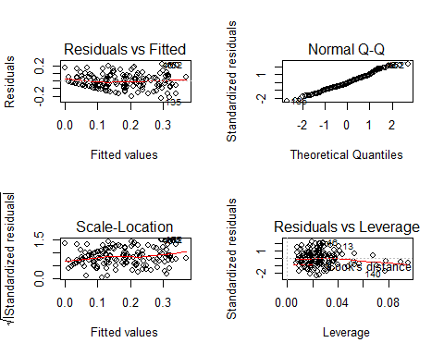

As Figure 29) shows, our situation has slightly improved, however the presence of others relevant outliers is still effecting the test. Nonetheless, on the basis of the statistical significance of our results, we argue here that the validity of our claim are solid enough, albeit not perfect. In this sense, more than persevering in the purge of our dateset, to the point of reducing the sample of our obesrvations untill we will eventually undermine any solidity our claims can possess, we suggest that we should wait to re run our model when more data, coming from a larger number of diverse countries, will become available as the Corona crisis keeps developing, influencing the lives of all of us.

As a last attempt, we will try now to add Healthcare Expenditure as an additional control variable. In the case that this addition will not improve the solidity of our models, we still, at least, expect to find confirmation of our results as exposed so far.

##   
## Figure 30) Alternative OLS Model: analysing the normalized number of deaths and controlling for democracy, healthcare quality, healthcare expenditure and press freedom  
## ==========================================================  
## norm_deaths   
## ----------------------------------------------------------  
## v2x_partipdem 0.247***   
## (0.089)   
##   
## Health_AQ 0.004***   
## (0.001)   
##   
## Health_GDP 0.007*   
## (0.004)   
##   
## Press.Freedom.Score 0.002**   
## (0.001)   
##   
## Constant -0.284***   
## (0.060)   
##   
## Observations 158   
## R2 0.470   
## Adjusted R2 0.457   
## Residual Std. Error 0.104 (df = 153)   
## F Statistic 33.984*** (df = 4; 153)   
## ----------------------------------------------------------  
## Notes: ***Significant at the 1 percent level.  
## **Significant at the 5 percent level.   
## *Significant at the 10 percent level.

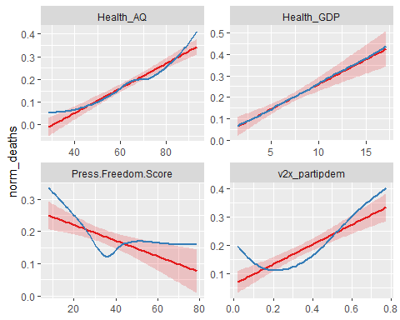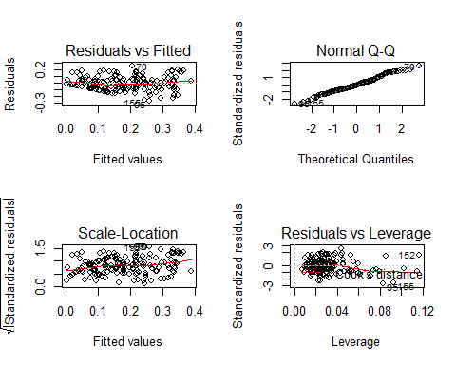

As the last three figure shows, albeit the control variable of Healthcare expenditure possess a lower grade of statistically significance in this alternative model, the addition of this control variables do confirm our assumptions.

CONCLUSIONS

The aim of this paper has been to deconstruct and consequentially reject a narrative on the ability of more autocratic regimes to tackle down the virus due to their intrinsic willingness to impose stricter measures on their citizens by means of military and police force, putting aside those social and ethical values that advanced democracies instead hold dear. We have argued that this narrative is dangerous, and most importantly flawed, because it does not take into consideration how relevant is the Freedom of the Press as a guarantor on the availability and reliability of information on the numbers and data concerning the coronavirus pandemic. By controlling for the freedom of the press, the quality of healthcare and the levels of democracy, we have depicted a different narrative, in which becomes clearly unreasonable to believe that those autocratic regime are simply more suited to counter this crisis. Considering how press freedom is abundantly correlated to higher levels of healthcare quality and democracy, we argue that it is decisively more reasonable to suspect that the lower number of reported cases and deaths, coming from those less-than-democratic regimes is more likely related to their disrespect for freedom of the press, and freedom of expression more broadly. Finally, we suggest that a similar model should be considered for further development once more data will be available, also including the numbers of reported test, that are now slowly but finally increasing.

BIBLIOGRAPHY

-Herszenhorn M.H, 2020, Democracy in Critical Care as Coronavirus Cisrupts Governments, in Politico;

-Human Rights Council, 2020, Disease Pandemics and the Freedom of Opinion and Expression, in Report of the Special Rapporteur on the Promotion and Protection of the Right to Freedom of Opinion and Expression;

-UNESCO, 2020, Press Freedom Critical to Countering COVID-19 ‘Pandemic of Misinformation’: UN Chief, In UN News.